Name- Jay S Maniyar

GR No- 1710982

Class – TY D

Roll No- 07

**Artificial Intelligence Home Assignment 1**

**Q] Implementing Tic-Tac-Toe using Non AI Method**

**Code🡪**

#include <iostream>

#include<conio.h>

using namespace std;

void printing(int **l)

{

cout << "\n-------------------------------\n";

for (int i=1; i <=3; i++)

{

for (int j = 1; j <=3; j++)

{

if (l[i][j] == 10)

cout << "|_X_| ";

else if (l[i][j] == 100)

cout << "|_O_|";

else

cout << " ";

}

cout << "\n";

}

cout << "\n----------------------------\n";

}

//Function for checking the winner

int decider(int **l)

{

int x = 0, y = 0;

for (int i=1; i <=3; i++)

{

x = 0;

y = 0;

for (int j = 1; j <=3; j++)

{

x = l[i][j] + x;

y = y + l[j][i];

}

/*after the process score required for user win is 300 while for system turns out to be 30

User Marks as 100 while system marks as 10 for each turn*/

if (x == 300)

return 2; //player wins

else if (x == 30)

return 1; //System Wins

if (y == 300)

return 2; //player wins

else if (y == 30)

return 1; //system wins

}

//Checking for left/first diagonal condition

x = l[1][1] + l[0][0] + l[2][2];

if (x == 300)

return 2; //User Won

else if (x == 30)

return 1; //Computer Won

//checking for second/other diagonal condition

x = l[1][1] + l[0][2] + l[2][0];

if (x == 300)

return 2; //player Won

else if (x == 30)

return 1;

return 0;

}

void computer_turn(int **l)

{

int x;

for (int i=1; i <=3; i++)

{

for (int j = 1; j <=3; j++)

{

//Checking for vacant spaces first

if (l[i][j] == 0)

{

//system's location denoted by j&i

l[i][j] = 100;

x = decider(l);

if (x == 2)

{

l[i][j] = 10;

return;

}

l[i][j] = 10;

x = decider(l);

if (x == 1)

{

l[i][j] = 10;

return;

}

l[i][j] = 0;

}

}

}

//For System should win

int max = 0, k, p, y, u, q;

for (int i=1; i <=3; i++)

{

x = 0;

y = 0;

for (int j = 1; j <=3; j++)

{

if (l[i][j] == 0)

{

y++;

k = i;

p = j;

}

else

if (l[i][j] == 10)

x++;

}

if (y>1 && x >= 1)

{

l[k][p] = 10;

return;

}

}

for (int i=1; i <=3; i++)

{

x = 0;

y = 0;

for (int j = 1; j <=3; j++)

{

if (l[j][i] == 0)

{

y++;

k = j;

p = i;

}

else

if (l[j][i] == 10)

x++;

}

if (y>1 && x >= 1)

{

l[k][p] = 10;

return;

}

}

for (int i=1; i <=3; i++)

{

for (int j = 1; j <=3; j++)

{

if (l[i][j] == 0)

{

l[i][j] = 10;

return;

}

}

}

}

int main()

{

int **l = new int *[3];//Allocating 2D array for each 1D ar

for (int i=1; i <=3; i++)

l[i] = new int[3];

for (int i=1; i <=3; i++)

for (int j = 1; j <=3; j++)

l[i][j] = 0;

//Default location for system is Centre of the matrix

l[1][1] = 10;

int p, q, x;

//Taking the input for the player side

printing(l);

for (int i=1; i < 4; i++)

{

cout << "Enter the row number for player to play : ";

cin >> p;

cout << "Enter the column Number for player to play : ";

cin >> q;

l[p][q] = 100;

x = decider(l); //calling the decider Function here

if (x == 1)

{

cout << ":Unfortunately The System has Won \n\n";

break;

}

else if (x == 2)

{

cout << ":Congratulations You have Won \n\n";

break;

}

computer_turn(l);

x = decider(l);////Checking if the Computer has won

if (x == 1)

{

cout << "****System Won*****\n\n";

break;

}

else if (x == 2)

{

cout << "*****You Won*****\n\n";

break;

}

printing(l);

}

printing(l);

getch();

return 0;

}

Output:

Draw Condition

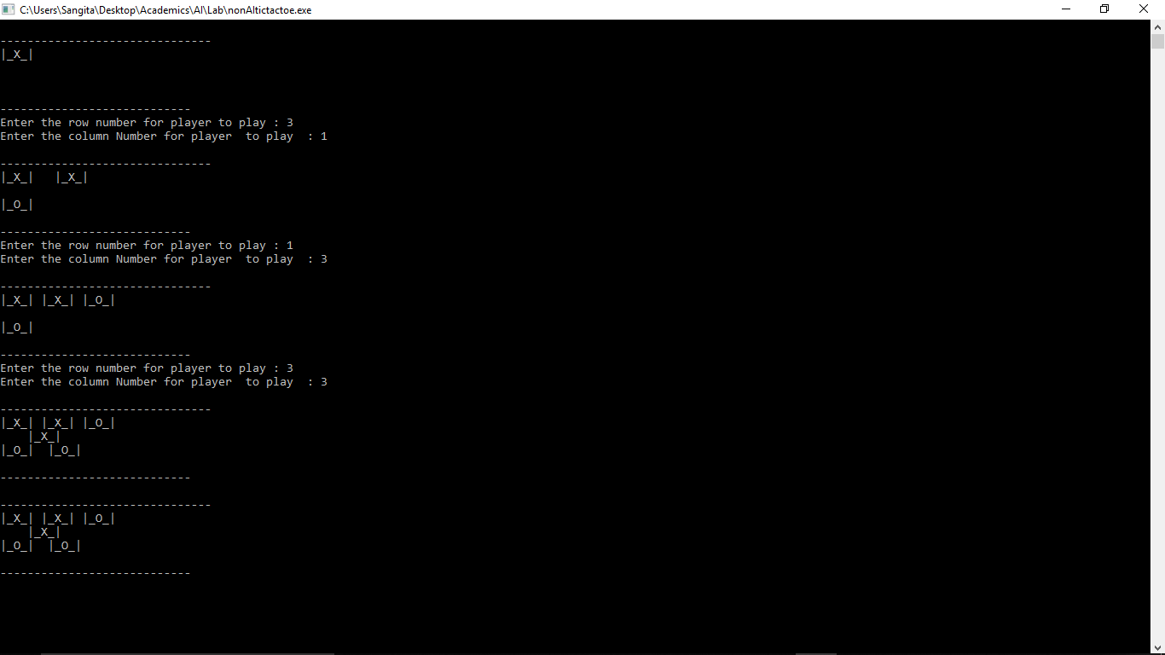

System Wins Condition

